Ogdensburg City School District

AIS/RTI Intervention Plan K-12

2022-2024

Academic Intervention Services (AIS)

Academic Intervention Services (AIS) means additional instruction which supplements the instruction provided in the general curriculum and assists students in meeting the NYS Learning Standards. Academic Intervention Services are intended to assist students who are at risk of not achieving the NYS Learning Standards in English language arts, mathematics, social studies and/or science, or who are at risk of not gaining the knowledge and skills needed to meet or exceed designated performance levels on state assessments. Academic Intervention Services shall be made available to English Language Learners and students with disabilities. In the case of AIS being provided to students with disabilities, services will be provided on the same basis as those provided to non-disabled students, as long as those services are consistent with the student’s individualized education program.

Academic Intervention Services includes two components:

• Additional instruction that supplements the general curriculum

• Student support services needed to address barriers to improved academic performance

Academic services will be provided to students in English language arts and mathematics in grades K-12 and social studies and science in grades 4-12. Support services will be provided to address barriers to increased academic performance related to attendance, behavior, family difficulties, health issues, lack of study skills, and transition or mobility issues.

Response to Intervention

Effective July 1, 2012, all school districts in NYS must have an RTI program in place as part of its evaluation process to determine if a student in grades K-4 is a student with a learning disability in the area of reading. The decision as to whether a student has a learning disability must be based on extensive and accurate information that leads to the determination that the student's learning difficulties are not the result of the instructional program or approach. RTI is an effective and instructionally relevant process to inform these decisions. NYS Regulations define RTI as a school district's process to determine if a student responds to scientific, research-based instruction, which minimally must include:

Appropriate instruction delivered to all students in the general education class by qualified personnel. Screenings administered to all students for the purpose of identifying those students who are not making academic progress at expected rates.

Instruction matched to student need with increasingly intensive levels of targeted intervention and instruction for students who do not make satisfactory progress in their levels of performance and/or in their rate of learning.

Repeated assessments of student achievement which should include curriculum-based measures. Written notification to the parents regarding the nature and scope of interventions.

Reviewed June 13, 2023

AIS/RTI Process

Procedures to Determine AIS Instructional Needs

Eligibility for AIS: Identification for AIS and intensity of service is based on multiple measures for each grade and subject area: Grades K-12 ELA and math, Grades 4-12 includes social studies and science. Students are identified for AIS at levels Tier 1-3:

Tier 1: Monitoring Tier 2 – Moderate Risk Tier 3 – High Risk

|  |  |  |
| --- | --- | --- |
| • Lack of skills needed to  maintain/monitor his/her own academic achievement (e.g., organizational skills, listening skills, test-taking skills, etc.)  • Grades K-3: does not meet  one criterion  • Grades 4-8: performing at or  below a median cut point  score between a Level  2/partially proficient and a  Level 3/proficient and/or do not meet one of the  benchmark criteria  • Grades 9-12: scores near  proficiency on the NYS  Regents and/or do not meet one of the benchmark criteria | • Are inconsistent in  demonstrating expectations of grade level. Consistently lack some specific skills that are required for satisfactory performance.  • Grades K-3: does not meet 2  benchmark criteria  • Grades 4-8: score a low  Level 2 below specified  scale score on NYS  Assessments and/or do not meet two of the benchmark criteria  • Grade 9-12: scores below  proficiency on the NYS  Regents and/or do not meet two of the benchmark  criteria | • Are potentially at-risk of not  achieving the New York  State Learning Standards  and/or meeting graduation requirements.  • Grades K-3: does not meet  at least 2 benchmark criteria • Grades 4-8: scores Level 1  on NYS Assessments and/or do not meet at least two of the benchmark criteria. The measure used, as well as  degree of discrepancy is  taken into account.  • Grades 9-12: scores below  proficiency on the NYS  Regents and/or do not meet at least two of the  benchmark criteria. The  measure used, as well as  degree of discrepancy is  taken into account |

Exiting AIS: Based on multiple measures

It is determined that a student is achieving the standards if they have:

• Achieved proficiency on the content area NYS assessment and/or

• Achieved the benchmark criteria on two or more of the multiple measures

Reviewed June 13, 2023

Subject and Grade

AIS/ RTI Criteria

Multiple Measures Benchmark Criteria

K-12 Student Attendance High rate of absenteeism may be related to academic difficulty

Data Team and/or Administrator Recommendation

Panorama

Comments from teachers are considered in overall evaluation

ELA K-6 SpeedDial/Dial 4 UPK September assessment Letter ID - Kindergarten 10

NYS ELA Assessment: Grades 3-6

Fountas and

Pinnell/Kaeden

Running Records

Benchmark Assessments K-6

NYS AIS cut score - at or below a median cut point score between a Level 2/partially proficient and a Level 3/proficient Benchmarked 2 to 3 times a year. Progress monitoring conducted for students not achieving the benchmarks. * Some students beyond grade 2 based on ability or need

IRA Grades 3-6 Benchmarked 2 to 3 times a year. Progress monitoring conducted for students not achieving the benchmarks.

iReady Reading

Grades K-6

ELA 7-12 IXL Reading

Grades 7-8

NYS ELA Assessment:

Grades 7-8

Panorama/ Progress

Monitoring 9-12

End of Year Classroom

Average 9-12

English Regents Grade

11

Math K-6 NYS Math Assessment: Grades 3-6

iReady Math

Grades K-6

Optional Math Running

Records

Standards Based

Assessments Grades K-6

Math 7-12 NYS Math Assessment: Grades 7-8

Benchmarked 3 times a year. Progress monitoring conducted for students not achieving the benchmarks (2x a year in Kindergarten) Benchmarked at least 3 times a year. Progress monitoring conducted for students not achieving the benchmarks. NYS AIS cut score - at or below a median cut point score between a Level 2/partially proficient and a Level 3/proficient Reviewed 2 to 3 times a year. Progress monitoring conducted for students not achieving the benchmarks.

65%

75%

NYS AIS cut score - at or below a median cut point score between a Level 2/partially proficient and a Level 3/proficient Benchmarked at least 3 times a year. Progress monitoring conducted for students not achieving the benchmarks. See attachment for benchmark chart.

Level 3 or 4

NYS AIS cut score - at or below a median cut point score between a Level 2/partially proficient and a Level 3/proficient

|  |  |
| --- | --- |
| End of Module  Assessments Grades 7-8 | Level 3 or 4 |

Reviewed June 13, 2023

Social Studies 3-12

IXL Math

Grades 7-8

Algebra I, Algebra II, and Geometry Regents NYS ELA Assessment Grades 4-8

Quarterly Social Studies grades

Benchmarked 2 to 3 times a year. Progress monitoring conducted for students not achieving the benchmarks. See attachment for benchmark chart.

Level 4-5

Students who score at levels 1 or 2 on the assessment at Grades 4-8 will be identified to determine whether their performance on the assessment is attributed to difficulty in areas of Social Studies content or reading and writing

65%

Global Studies Regents 65%

Science 3-12

United States History and Government Regents NYS Science

Assessment at Grades 5 and 8

NYS ELA Assessment and NYS Math

Assessment

Physical Settings in Earth Science and Living

Environment Regents, Chemistry and Physics

65%

Level 3 or 4

Students who score at levels 1 or 2 on the assessment in Grades 4 - 8 will be identified to determine whether their performance on the Science assessment is attributed to difficulty in the areas of reading, writing and math.

65%

|  |  |
| --- | --- |
| NYS Science  Investigations Grades 3-5 and 6-8 | Follow scoring rubric using a 4-point scale |

Reviewed June 13, 2023

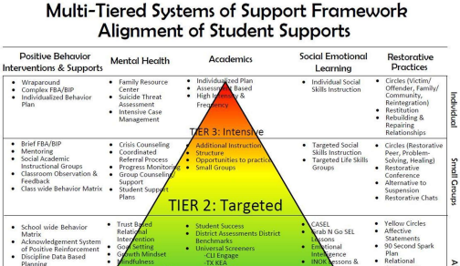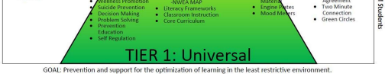Reviewed June 13, 2023

AIS/RTI K-12 Program Description

Tier 1 – Monitoring Tier 2 – Moderate Risk Tier 3 – High Risk

Intensity of service

Core Instruction for all students

In addition to core instruction: Minimum 3 times a cycle for 30 minutes

Grades K-6 additional support provided in Math AIS

Grades 7-12: Additional support provided through small class size, extended time, push in services or pulled out for services

Targeted support

provided in addition to Tier I at least service 3 times a week

Grades 7-12: pull out in addition to Tier 2

Grouping Differentiated small group instruction

Staffing Classroom teacher supported by AIS teacher, teaching

assistant and special

education teacher as

schedules allow

Grades K-6: Small groups of 5 students or less

Grades 7-12: Small groups 3- 12 students

AIS teacher, classroom teacher, special education teacher and teaching assistant

Grades K-6: Individual or small group 1-3 students

Grades 7-12: Groups of 3-11 students (labs) AIS teacher, special education teacher

|  |  |  |  |
| --- | --- | --- | --- |
| Program/  Instructional  Support | • Differentiated  instructional strategies  used in the regular  classroom are: preferential seating, reduce number of items expected to be  worked on by student  (homework and  classwork), read  directions, simplify  concepts, extend  timeframes, use Effective Teaching Strategies  • Classroom teachers will  identify similar skill needs and use flexible grouping for instruction based on  student need | • Tier 1 support  • Small group with similar  needs instruction and  collaboration with  classroom teachers  • Extended courses with  small class size and/or  additional teacher | • Tier 1 support  • Tier 2 support as  schedule allows  •Individual or small  group instruction for high-needs students as schedule allows  • Other support may  include: special  education support |

Reviewed June 13, 2023

Student Support Services

Student Support Team (Elementary) Child Study Team (MS/HS)

• Meets at least monthly to brainstorm/plan effective teaching strategies and programs for students.

School Counselor

• Works with individuals as determined by the Student Support Team/ Child Study Team.  • Classroom visits K-6/SEL focus

• Coordinates services with classroom teachers and all other staff who have contact with that student  (i.e., special education, Title I and special areas)

• Behavior Interventions/ICMP

• Liaison with community organizations

Migrant Education

• Migrant Tutors

SLPC

• MIT – Mobile Integration Team

• SPOA- Single Point of Access

• Respite House

•Individualized in-school counseling

Guidance Services

After School Program Grades K-6

Boys and Girls Club – Grades K-12

Builders Club Grades 7-8

Peer Tutors Grades 7-12

K-Kids Grades K-6

Liberty Partnerships

Little Something Extra Program Grades K-12 (Pantry)

McKinney-Vento Title I Mentors

School Based Social Services

Children's Advocacy Group

PTO

Renewal House

Second Step

Smart Scholars – Partnership with SUNY Canton

Snack Pack Program Grades UPK – 6

SLU Tutors – Grades K-8

Student Council Grades 3-12

Social Workers K-12

Teacher Mentoring

WEB Program

YAP - Youth Advocacy Program

Positivity Project

United Helpers/Care Coordinators

Life Plan Care Coordination of New York

Transitional Living Services

TCIS- Therapeutic Crisis Intervention for Schools

NYSARC

Probation (PINS)

Reviewed June 13, 2023

SRO

Harvest of the Month (Elementary Schools)

Student Support Recovery (7-8)

Alliance (9-12)

ICU Data Base (Email/text for missing assignments sent to parents 7-8) Academic Lifeguard (7-8)

Summer School- Credit Recovery (7-8)

Summer School- Regents Class-in-person review (9-12)

Parent and Family Engagement Requirements

Notification of AIS/RTI Services

• District notification letter to include:

o dates when service will start

o reasons why student needs AIS:

• subject area(s) identified

• results of multiple measures

• summary of services to be provided

• student support services to be provided

• frequency and intensity of service

• expectations of students in relation to grade level performance

• consequences of not achieving expected performance levels

• Additional notification required for RTI grades K-6 reading and math  o strategies for increasing the student’s rate of learning; and

o the parents’ right to request an evaluation for special education programs and/or services.

Notification of End of AIS/RTI Services

• District notification letter to include:

o when services are to be discontinued

o overview of student’s progress

▪ performance level student has attained to qualify for ending AIS (results of multiple measures)

▪ assessments used in determining students’ levels of performance

Ongoing Communication

• Fall/Spring teacher conferences/Open House

• Trimester reports

• Phone calls/emails

• District and Title I newsletters

• District and school websites

• Parent conferences or other informal consultations each semester • Suggestions for working with students at home

• Google Classroom

• Social Media (ie: Facebook and (website) OCSD App)

• Parent Square

• Home visits

Reviewed June 13, 2023

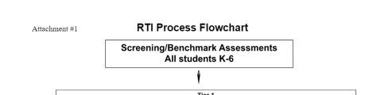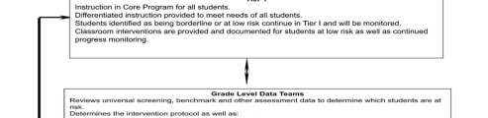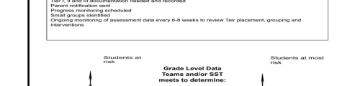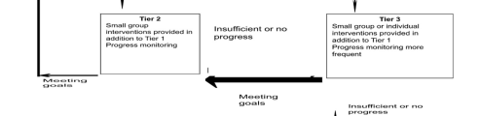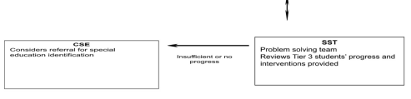

Reviewed June 13, 2023

Attachment #2

Grades K-6 RTI Problem Solving Process - Responsibilities

Classroom Teachers

Grade Level

TeamsIntervention Providers

Student Support

TeamCSE Team

|  |  |  |  |  |
| --- | --- | --- | --- | --- |
| • Core instruction  • Benchmark and  progress monitoring  assessments  • Tier 1 interventions (small group,  differentiated, during  the uninterrupted  block)  • Documentation of Tier 1 interventions | • Grade level teams include:  Classroom teachers  Intervention  providers  Others  • Analyze data to  inform instruction  using:  Core assessments  Diagnostic  assessments  • Determine Tier 1 and Tier 2 groupings,  discuss need for Tier 3 interventions  • Provides  documentation of  decisions made re:  instructional changes | • Tier 2 interventions in addition to Core (Tier 1) instruction  • Progress monitoring and diagnostic assessments  • Documentation of Tier 2 interventions  AND  • Tier 3 interventions in addition to Tier I  • Progress monitoring and diagnostic assessments  • Documentation of Tier 3 interventions | • Multi-disciplinary team includes:  Classroom teachers  Special education teacher Psychologist  Principal  Intervention providers Speech and Language Social Worker  Counselor  • Students reviewed when no significant progress has  been made at Tier 2 and/or Tier 3  • Reviews documentation of Tier 1, 2 and 3  interventions  • Uses problem solving model to recommend  further instructional  changes or interventions to be tried, along with ways to document the effectiveness of the changes  • Makes referral to CSE when necessary | • Multi-disciplinary team  • Analyzes data  • Reviews  documentation of  Tier 1, 2,3  interventions  • Decides what  additional CSE  services to  provide to enable  the child to be  successful |

Reviewed June 13, 2023

Reviewed June 13, 2023