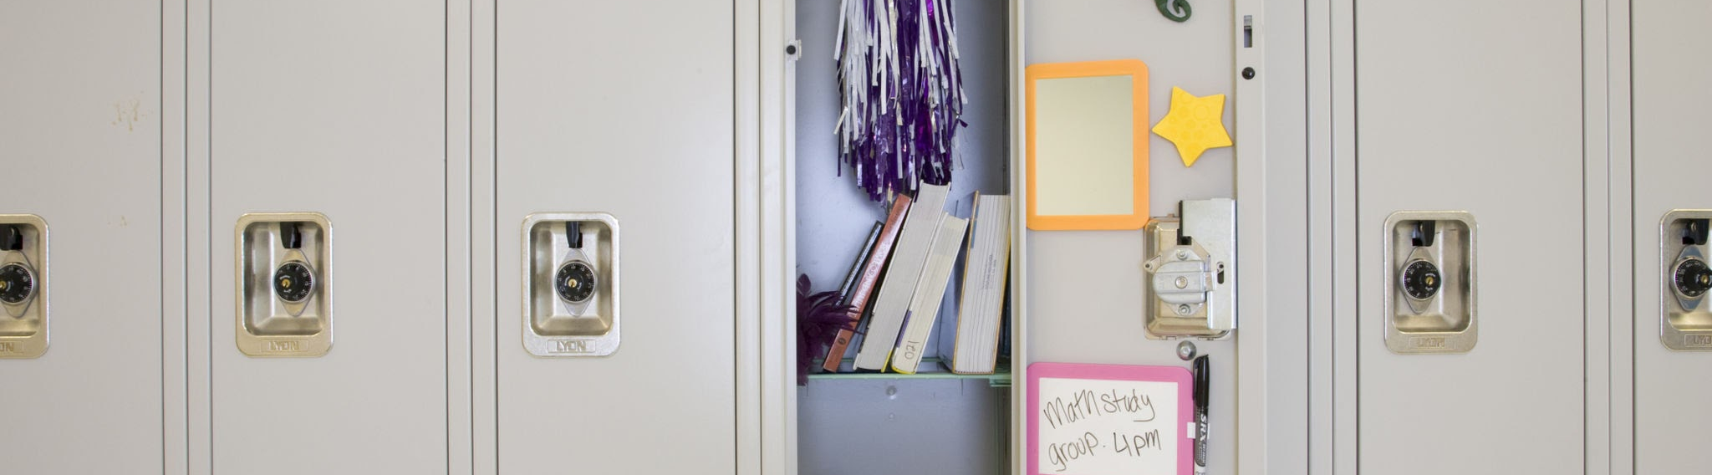
New York State
Assessment Data for 2023-2024
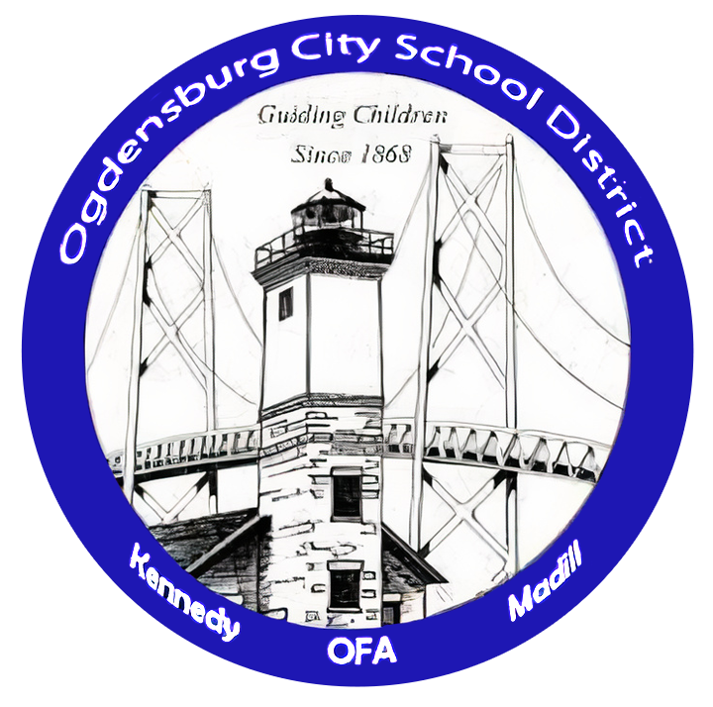
Ogdensburg City School District
Brooke Reid, Assistant Superintendent for Curriculum,
Instruction, Technology & Assessment

3-8 ELA & Math Assessment Data Includes:

- Percent Proficient (Grade Level)
- Proficiency Standings in the SLLBOCES
- Performance Comparison (SLL BOCES & RIC)
(18 public school districts in St. Lawrence County)

Proficiency Standings in BOCES
ELA
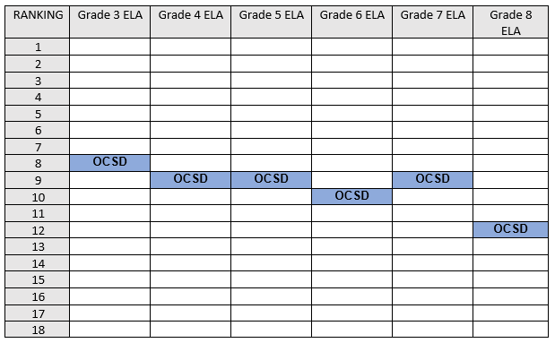
MATH
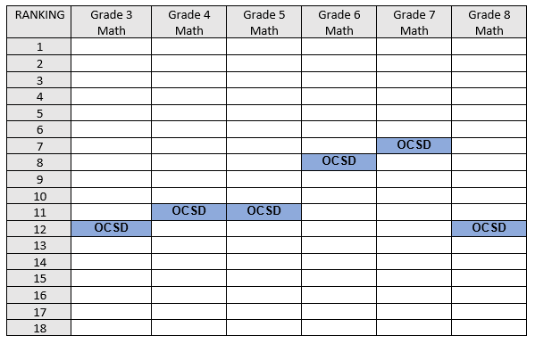

SLL BOCES Overall Ranking
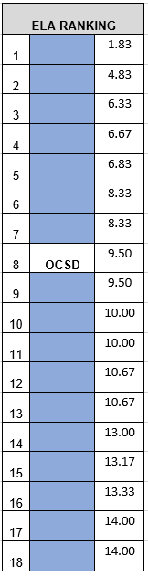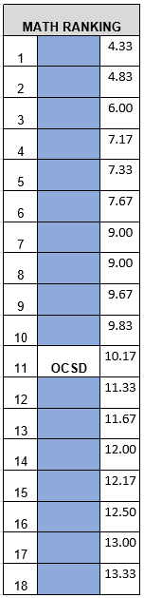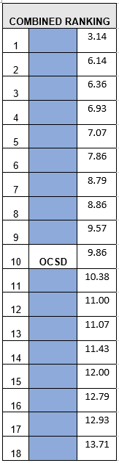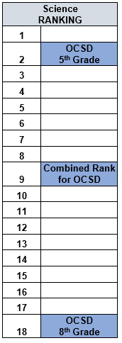
3rd-8th Assessment Proficiency
ELA
Math
Science

Overview of All 3rd-8th Grade Assessments
