Ogdensburg Free Academy Class of 2025
Valedictorian
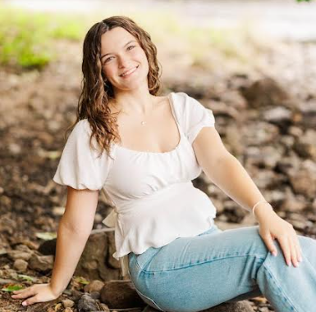

Miss Gabriella Ott, daughter of Mr. William and Mrs. Tonya Ott of Ogdensburg, NY, represents her class of 117 seniors as the valedictorian with an overall grade point average of 99.18.
Gabriella will graduate in June 2025 with a Regents Diploma with Advanced Designation with Honors, showcasing her mastery in mathematics and science. Her dedication to academics is evident, receiving an invitation to the Academic Recognition Ceremony each year of her high school career. Her Advanced Placement test scores have earned her the AP Scholar with Honors designation.

Gabriella’s dedication extends beyond the classroom. She is an active member of National Honor Society, performs vocal music, and plays the clarinet. She has been involved in concert band, jazz band, marching band, pep band, and has represented OFA in All-County and Area All-State bands. She has performed in the jazz rock choir and senior chorus and has been selected to perform vocal NYSSMA solos. Her love for music is matched by her enthusiasm for musical theater, where she has earned roles in school and community productions.

In addition to her musical pursuits, Gabriella is a Varsity swimmer, competition cheerleader, and softball player. She has been enrolled in dance classes since pre-school, further demonstrating her commitment to the arts.

Gabriella is the Alan Krause Citizenship Award recipient and was featured as an
Academic All-Star on WWNY TV7 News at Noon.

Gabriella will pursue a major in medical lab technology at Binghamton University.
Ogdensburg Free Academy Class of 2025
Salutatorian

Miss Brooke Barr, daughter of Mr. Steven and Mrs. Renee Barr of Ogdensburg, NY, represents her senior class of 117 students as salutatorian with a grade point average of 98.59. Brooke has consistently held second rank in her class throughout her high school journey. This June, Brooke will graduate with a Regents Diploma with Advanced Designation, showcasing her mastery in
mathematics and science.

During her time at Ogdensburg Free Academy, Brooke has participated as an active member of the National Honor Society and Student Council. She has also
competed as a three-season athlete and participated in volleyball, cheerleading, and softball. Brooke’s leadership qualities have been exemplified by her role as captain on her volleyball and cheerleading teams.

Brooke was named to two first-team All-Northern teams in cheerleading, first and second-team All- Northern in volleyball, and a second-team All-Northern in softball. Additionally, she has been honored as a Section X Senior Athlete of Distinction and a NYSPHSAA Individual Scholar Athlete.

Balancing a rigorous course load including several Advanced Placement and dual enrollment courses, Brooke has excelled academically while maintaining her athletic commitments and responsibilities. During the summer, Brooke balances multiple jobs, working as a lifeguard at the Ogdensburg City Pool and Lisbon beach, and serving as a recreation worker for the city.

Brooke intends to pursue a career in healthcare, and has been accepted for direct entry into a physician assistant program.

